Prepared by Lani L April 4, 2026

2024

HR Attrition Analysis Report
  - prepared by Lani Lovett

Workforce Attrition Analysis Report: Smithsonian Co.
Define Key Terms
Attrition: The reduction of employees through voluntary resignations, retirements, or other departures without immediate replacement.
Voluntary Quit: An employee who resigns by choice.
High-Attrition Role: A position experiencing employee departures at a significantly higher rate than the organizational average.
Hiring Buffer: Additional staff hired above projected needs (10–15%) to compensate for expected future attrition.

Introduction
Why This Analysis Was Conducted
Smithsonian Co. is experiencing a workforce shortage due to an ongoing strike involving 15 sales associates and 23 research scientists. To maintain business continuity and prepare for normal employee turnover in addition to the current staffing disruption, management is considering hiring 10–15% more employees than standard workforce projections.
This report analyzes historical employee attrition to identify workforce trends, estimate future hiring needs, and support data-driven recruitment planning.

Business Context and Stakeholders
Organization
Smithsonian Co. (Multi-department organization)
Deliverable Audience
- Executive Leadership
- Human Resources Department
- Talent Acquisition Team
- Operations Management
Stakeholders
- Chief Executive Officer (CEO)
- Human Resources Director
- Recruitment Managers
- Department Managers
- Finance Department
- Workforce Planning Team

Objectives
The objectives of this analysis are to:
- Identify the roles with the highest attrition rates.
- Determine when employee resignations most frequently occur.
- Calculate the average salary of employees who leave the organization.
- Identify demographic or organizational factors associated with higher attrition.
- Estimate additional hiring requirements to offset expected future attrition.
- Provide evidence-based recommendations for workforce planning during the current staffing shortage.

Data and Methodology
Data Sources
Primary Dataset(s):
- Human Resources employee records
- Payroll and salary data
- Employment history
- Job role and department information
- Employee demographic information
Data Cleaning
- Removed duplicate employee records.
- Standardized department and job titles.
- Corrected missing or inconsistent values.
- Removed incomplete records where necessary..

Analytical Techniques
Descriptive Analysis
- Employee count: 1,470
- Number of voluntary quits: 237
- Attrition rate: 16.1%
- Departments analyzed: Sales, Research & Development, Human Resources
- Job roles analyzed: 9
Comparative Analysis
- Attrition by department
- Attrition by job role
- Attrition by salary band
- Attrition by age group
- Attrition by gender (if applicable)

Findings and Visualizations
  - Roles with the Highest Attrition
Highest attrition position:
- Sales Representative
- Overall Attrition Rate: 16.1%
Top Five Roles
Rank | Role | Attrition Rate
1 | Sales Representative | 39.8%
2 | Laboratory Technician | 23.9%
3 | Human Resources | 23.1%
4 | Sales Executive | 17.5%
5 | Research Scientist | 16.1%

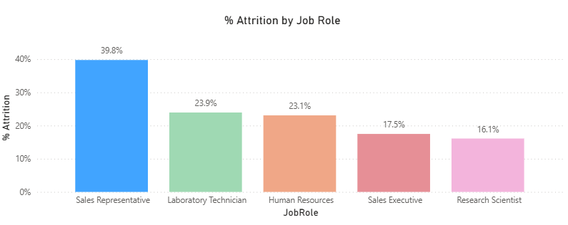
Average Salary of Employees Who Quit
Average salary:
$57,445
Salary range with highest turnover:
$1,000-$2,000
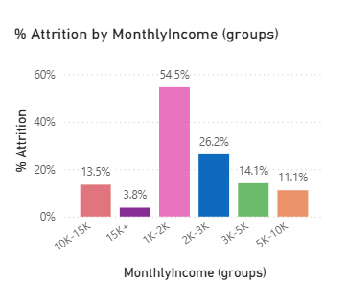

Other Notable Factors
Department with Highest Attrition:
Sales
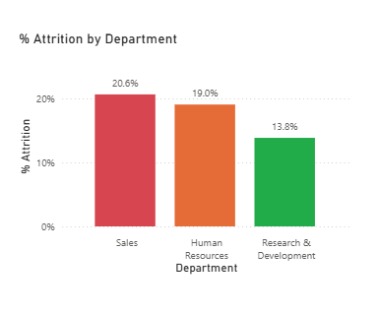
Highest-Risk Age Group:
Employees aged 18–25 had the highest attrition rate (35.8%), compared with 9.2% among employees aged 36–45.
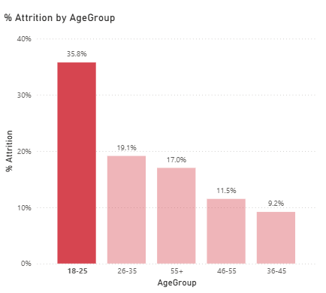

Highest Education Level Leaving:
1. High School Diploma/GED
2. Bachelor’s Degree
Bachelor and High School Diploma/GED make up almost 50% of attritions.
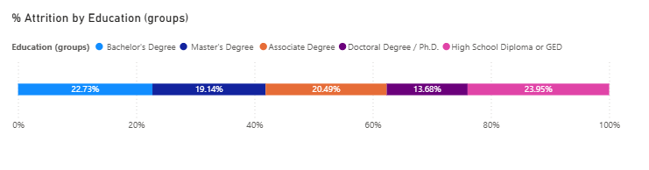

Attrition by Overtime Relationship:
Employees with overtime were 3X more likely to attrite.
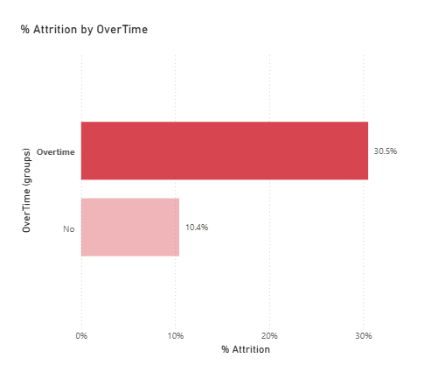

Job Satisfaction Relationship:
Highest attrition rate for low job satisfaction at 22.8%
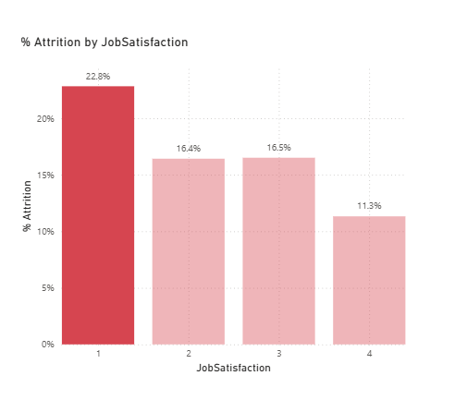
Distance from Work:
Longer distance correlated with higher attrition.
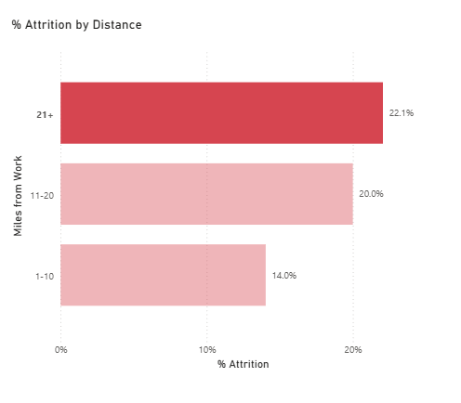
Promotion History:
16.3% NOT due for promotion | 12.5% due for promotion
Work-Life Balance:
Those with Burnout/Unsustainable workload are twice as likely to attrit than those with a manageable workload.
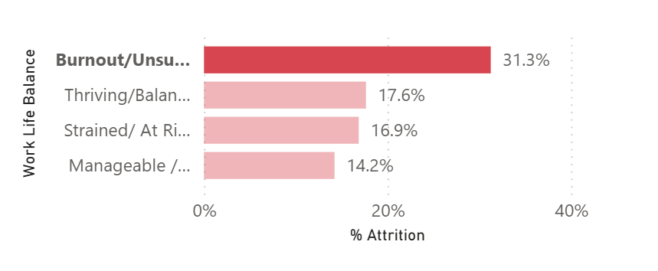
Other Significant Findings
- Males were twice as likely to attrit.
- Monthly income of 1K-5K is at higher risk for attrition (21.8%).

Discussion / Interpretation
The analysis indicates that the greatest workforce risk exists within Sales/Sales Rep where attrition reached 39.8%, exceeding the organizational average of 16.1%.
Employee departures most commonly occurred after approximately 1 year of service, suggesting a potential retention challenge during this stage of employment.
Employees leaving the organization earned an average salary of $57,445, indicating that turnover is concentrated within the mid salary range.
Significant factors associated with increased attrition included:
- Monthly income: under 2K
- Age: 18-25
- Job Role: Sales Representative
- Burnout has the highest turnover with 31.3% of employees attriting.
Considering the current strike affecting 15 sales associates and 23 research scientists, maintaining existing staffing levels will require proactive recruitment to offset both the immediate shortages and expected future attrition.
Limitations
This analysis has several limitations. The dataset did not include employee departure dates, which limits the ability to accurately identify seasonal trends, specific periods of increased turnover, or when resignations most frequently occurred. Without this information, timing-related attrition patterns could not be fully evaluated.
Additional limitations may include incomplete employee records, limited access to qualitative factors influencing turnover (such as employee satisfaction or workplace concerns), and reliance on available historical data to estimate future staffing needs.

Recommendations and Action Plan
Short-Term Actions
- Recruit replacements for striking positions immediately.
- Hire an additional 10–15% above projected staffing requirements.
- Prioritize recruitment for the highest-attrition roles.
- Accelerate onboarding processes.
Medium-Term Actions
- Review compensation for high-turnover positions.
- Strengthen employee retention initiatives.
- Improve career progression opportunities.
- Conduct stay interviews with high-risk employee groups.
Long-Term Actions
- Develop predictive attrition monitoring dashboards.
- Implement workforce planning based on historical turnover trends.
- Regularly review hiring forecasts using updated attrition data.
- Measure retention initiatives through quarterly reporting.

Conclusion
Historical attrition analysis provides Smithsonian Co. with evidence-based insights for workforce planning during the current hiring crisis. By identifying high-turnover roles, understanding when employees are most likely to leave, and estimating future staffing needs, the organization can make informed hiring decisions while maintaining operational continuity.
Hiring an additional 10–15% above normal workforce requirements is expected to reduce staffing risk and improve resilience against both ongoing labor disruptions and routine employee turnover.

Appendix (Optional)
Key Metrics
Metric | Value
Overall Attrition Rate | 16.1%
Total Employees | 1,470
Total Employees Leaving | 237
Highest Attrition Role | Sales Representative
Highest Attrition Department | Sales
Average Salary of Employees Leaving | $54,445
Average Tenure Before Leaving | 1 year
Recommended Additional Hiring | 36 employees (10–15%)

